*Low Level Design - <Project Name>*

**Document ID:** < Use Case Number >

**Last Reviewed by:** <user name>

**Version:** 2.1

**Date: Jan 25, 2022**

Table of Content

**1.** **Introduction 2**

**2.** **Design Approach 2**

2.1 Approach 1 2

2.2 Approach 2 2

2.3 Selected Approach 2

**3.** **Class Diagram 2**

**4.** **Detailed Interaction Diagram 2**

**5.** **Presentation Layer 2**

5.1 Screens 2

5.2 Reports 3

**6.** **Business Layer 3**

**7.** **Database Layer 4**

**8.** **Detailed Design to Functional Requirement Cross Reference Matrix 4**

**9.** **Build Process 4**

**10.** **Definitions and Acronyms 4**

# **Introduction**

In this document we have given the detailed description Aspire Overflow

# **Design Approach**

<List the approaches analyzed to provide a solution for the requirement under consideration>

## **Approach 1**

<Details of the approach>

## **Approach 2**

<Details of the approach>

## **Selected Approach**

<Selected approach with the reason for selection must be provided in this section>

# **Class Diagram**

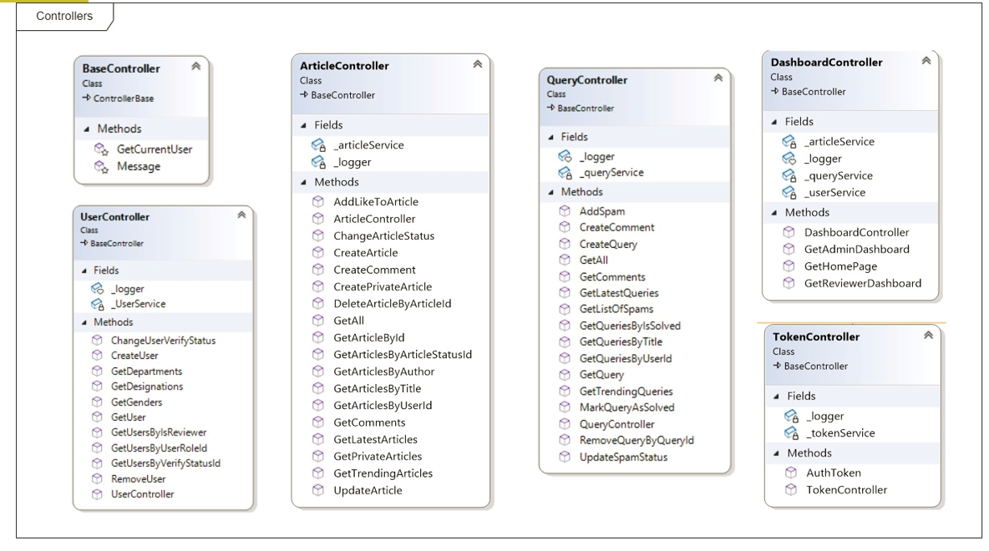

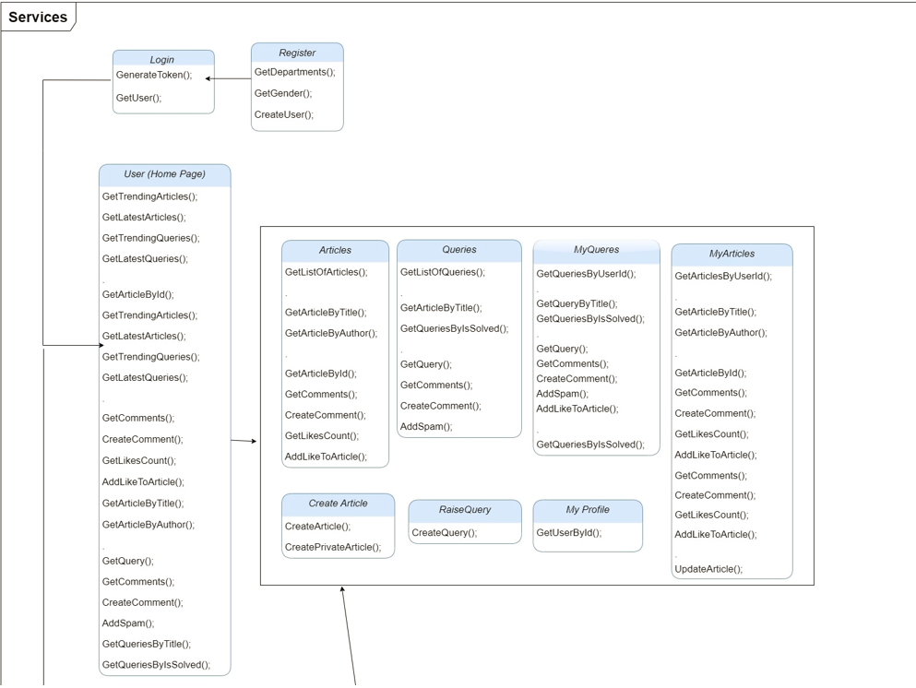

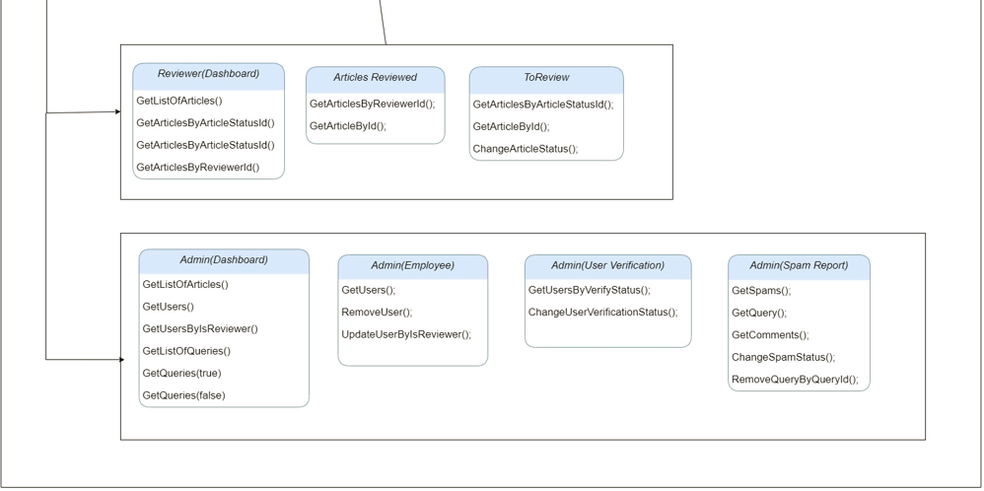

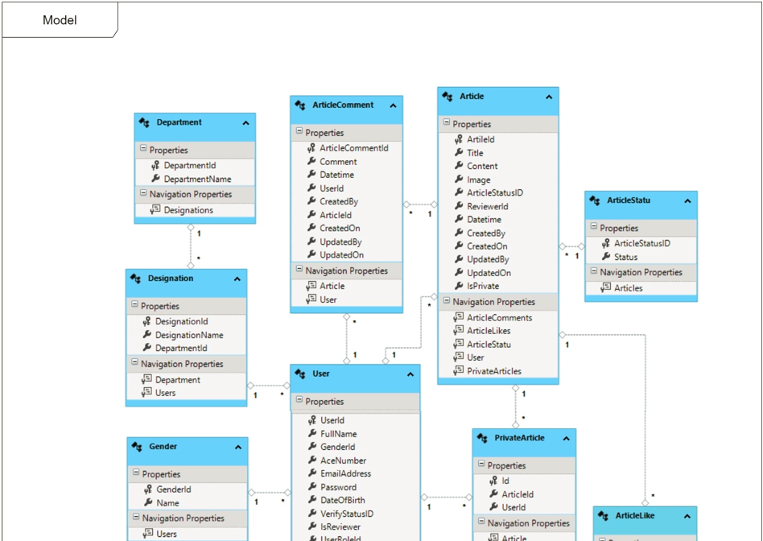

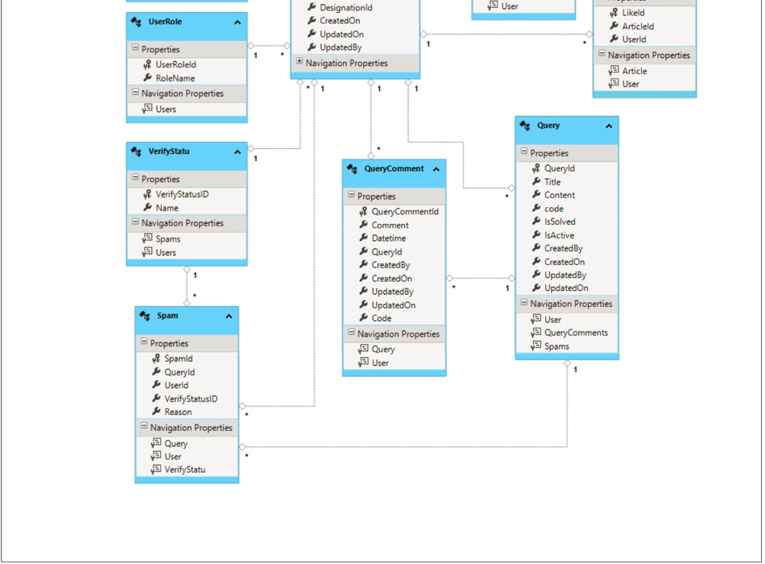

# **Detailed Interaction Diagram**

<The Sequence diagram for all the identified use case scenarios from the requirements using the classes detailed in the class diagram section>

# **Presentation Layer**

## **Screens**

**SCREEN 1 – LOGIN PAGE**

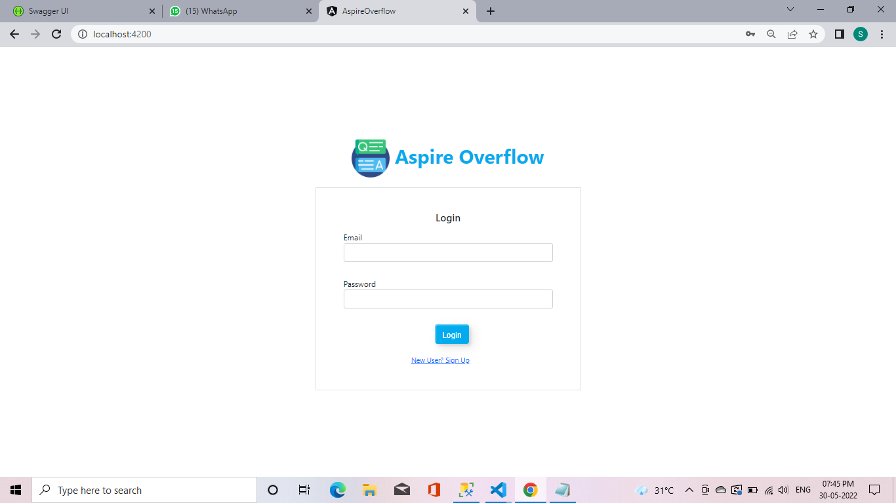

| **Description** | Purpose of the Screen - Here the User can Login after successfully Register his account. |
| --- | --- |
| **Security Group** | List the security groups that may use the screen |
| **Data** | Here User enter his Email id and password after that user click login button.If the Email id and password should be matched means User should go for home page Otherwise User should be return back to Login page. |
| **Actions** | Login Button – After user enter his email id and password ,then user click Login button that button should go to homepage. |

**SCREEN 2 – REGISTER PAGE**

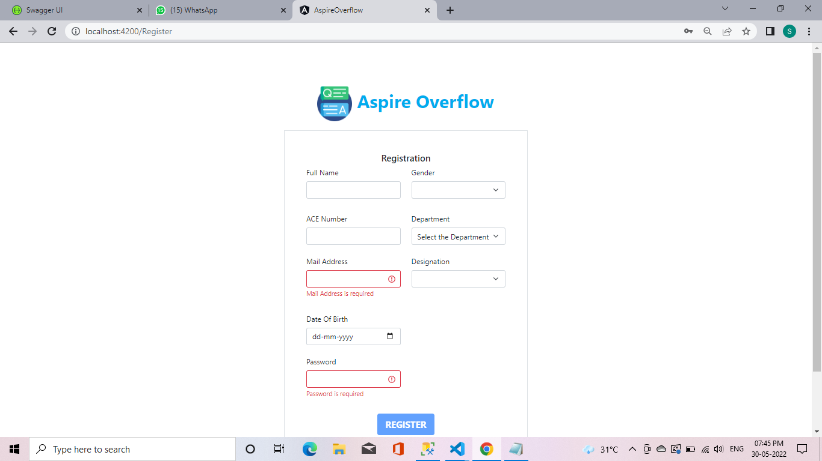

| **Description** | Purpose of the Screen - Here the new User want to view Articles, query, Write articles and publish, Query raiser, Query solver Whatever he/she can do in this web application. New user can register her details then only he/she can do. Otherwise he/she cannot do anything. |
| --- | --- |
| **Security Group** | List the security groups that may use the screen |
| **Data** | Here User enter his Full name, ACE Number, Mail Address, Date of Birth, Password, Gender, Department,Designation.  All the field are required If the new user cannot fill some asked Details mean he/she cannot create his account.  Also, some validation done by Developer (User name should be not less than 8 characters. Ace number should be Starting with alphabet and remaining all number (Ex:- ACE3690).Mail address should be alphabet Uppercase, Lowercase, @ symbol and end with .com. Password should be not less than 10 character special character also used. |
| **Actions** | Register Button – After user enter his details, then user click Register button .If the user enter his details correctly means Registration process done.If he/she cannot fill some Required details means his could not registered. |

**SCREEN 3 – HOME PAGE**

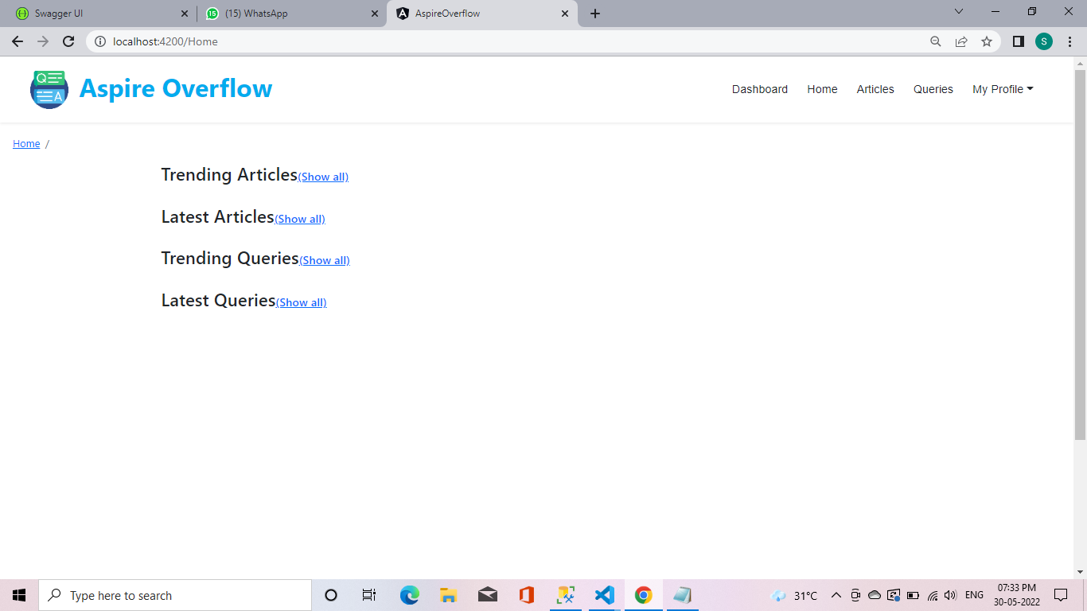

| **Description** | Purpose of the Screen - Here the User can see the Trending Articles, Latest articles,Trending queries,Latest Queries and his profile. |
| --- | --- |
| **Security Group** | List the security groups that may use the screen |
| **Data** | Here the user can view the the Trending Articles, Latest articles,Trending queries,Latest Queries.  Trending Articles: - It should be based on more Likes, Views and Shares.  Latest articles: - It should be based on Articles published in recent time.  Trending queries: - It should be based on more Likes, Shares and Comments.  Latest Queries: - It should be based on Query raised in recent times. |
| **Actions** | My Profile: - Here the user can see his Profile.  Articles: - Here the User can click articles means It can go to Article page and see more articles here.  Queries: - Here the User can click queries means it can go to Query page and view more query here.  Show all:-Here the user click show all means,it should go to all Trending Articles, Latest articles,Trending queries, Latest Queries. |

**SCREEN 4 – ARTICLE PAGE**

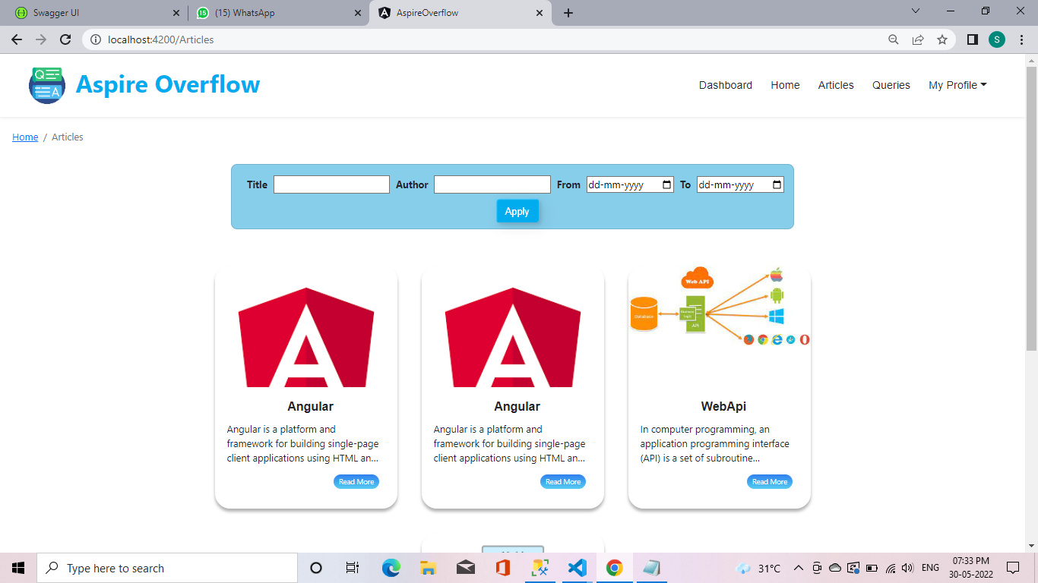

| **Description** | Purpose of the Screen - Here the User can see the all articles and also User can see the article by Title,Author and date. |
| --- | --- |
| **Security Group** | List the security groups that may use the screen |
| **Data** | Title:- Article should be shown based on the title given by the user.  Author:- Here the article should be shown based on that author name given by the user.  Date:- Here the user should give the date(From – To).Based on that Listed article should be shown in that particular date. |
| **Actions** | My Profile: - Here the user can see his Profile.  Articles: - Here the User can click articles means It can go to Article page and see more articles here.  Queries: - Here the User can click queries means it can go to Query page and view more query here.  Apply button:- After user enter Article name,Author name or date.then user click apply button if it is available means shown otherwise not shown.  Read more:- Here the user click read more means,It should view full article. |

**SCREEN 5 – QUERY PAGE**

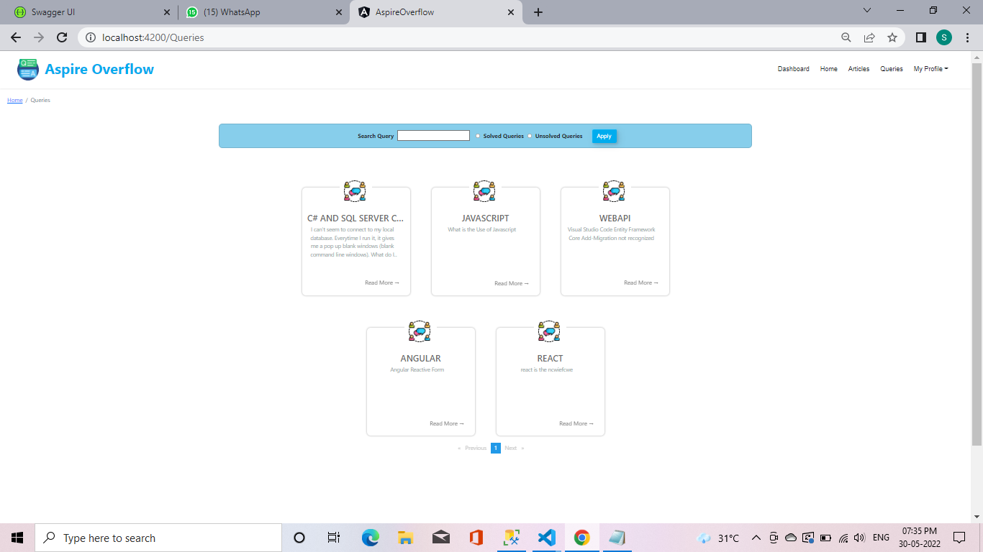

| **Description** | Purpose of the Screen - Here the user can see the all queries and also user can see the query by search query,solved and unsolved query. |
| --- | --- |
| **Security Group** | List the security groups that may use the screen |
| **Data** | Search query:- Here the user can search query based on what he/she need.if that user searched query available means user can use the query.Suppose if that query not available means that query should be marked as unsolved.  Solved queries:- Here the user can view all the solved queries and also user can answer the queries if user know the additional answers.  Unsolved queries:- Here the user can view the unsolved queries and also user can give the answer if he/she know the queries answer. |
| **Actions** | My Profile: - Here the user can see his Profile.  Articles: - Here the User can click articles means It can go to Article page and see more articles here.  Read more:- Here the user click read more means,It should view full query .  Queries: - Here the User can click queries means it can go to Query page and view more query here.  Apply button:- After user enter query.then user click apply button.If it is available means shown otherwise not shown. |

**SCREEN 6:- VIEW QUERY**

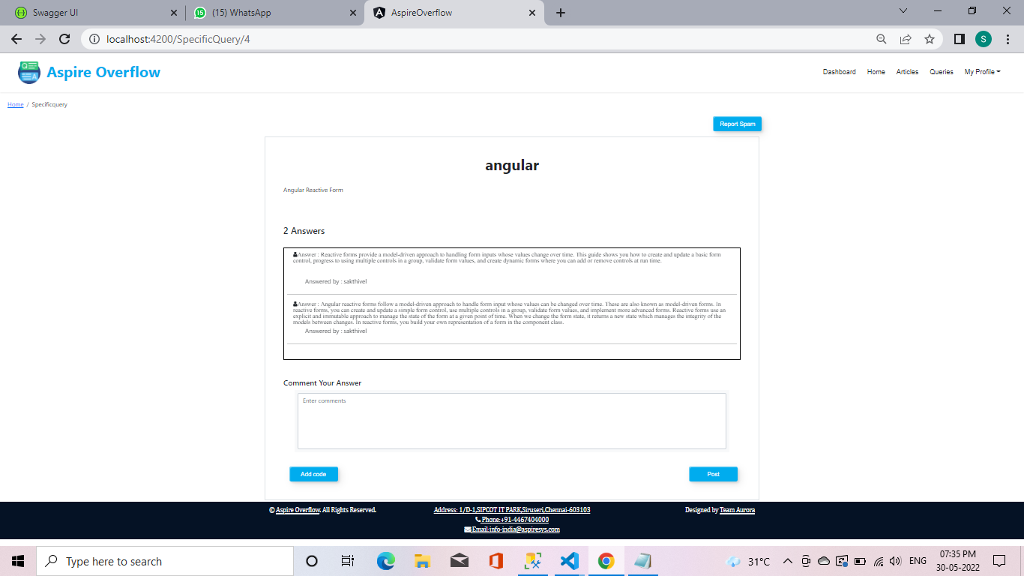

| **Description** | Purpose of the Screen - Here the user can view the particular query and also user can add comment and report as spam. |
| --- | --- |
| **Security Group** | List the security groups that may use the screen |
| **Data** | Comment your answer :- Here the user can write the answer. if the user known the above question.  Add code:- Here the user also submit code(Ex:- c,c++). |
| **Actions** | Post button:- Here the user can write his answer.then user enter post means that answer should be posted in that particular query.  Report spam:- Suppose the given content/query is dirty means the user can report as spam and also he/she should mention reason why should reported as spam. |

**SCREEN 7:- REPORT SPAM PAGE**

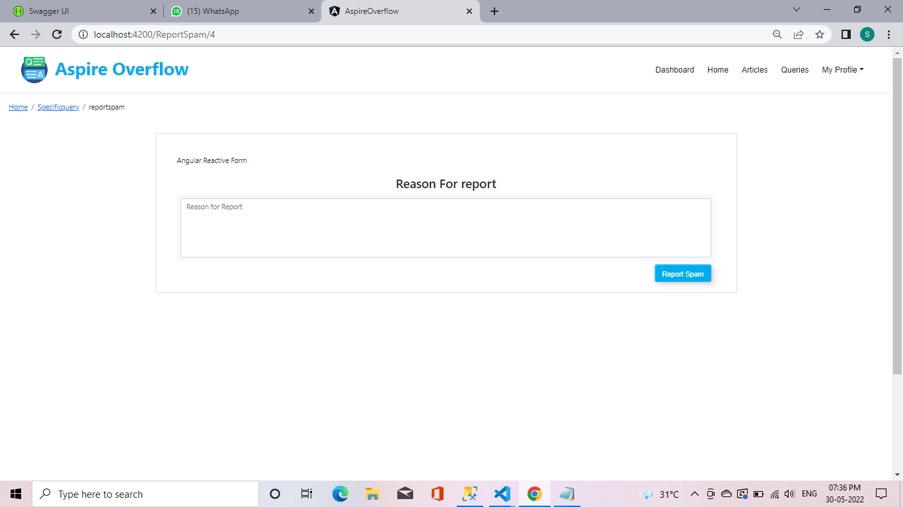

| **Description** | Purpose of the Screen - Here the user can mentioned that the particular query as spam means user should enter the reason for that query why that query mentioned as spam. |
| --- | --- |
| **Security Group** | List the security groups that may use the screen |
| **Data** | Reason for spam:- Here the user should write the reason why he/she reported as spam and also that column is required one. |
| **Actions** | Report spam button: - After enter the reason the user should enter the report spam button.That reported content should be stored.  If there is no content ,user click report spam button means there should be mentioned as that is required one. |

**SCREEN 8:- CREATE ARTICLE PAGE**

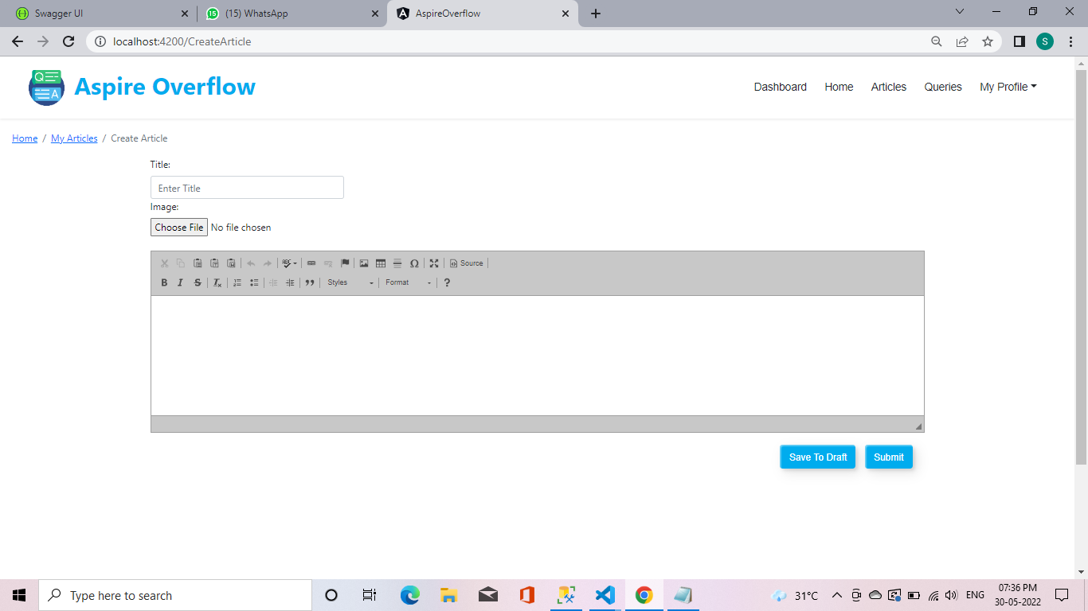

| **Description** | Purpose of the Screen - Here the User can create new Article. |
| --- | --- |
| **Security Group** | List the security groups that may use the screen |
| **Data** | Title:- Here the user can mention article title.  Image:- Here the user can mention image for his article.  Content:- Here the user can write the article |
| **Actions** | My Profile: - Here the user can see his Profile.  Articles: - Here the User can click articles means It can go to Article page and see more articles here.  Queries: - Here the User can click queries means it can go to Query page and view more query here.  Save to draft:- Here the user article is in completed means ,User can saved this article as draft.  Submit button: - Here the user should submit the article if he/she is completed. |

**SCREEN 9:- MY ARTICLE**

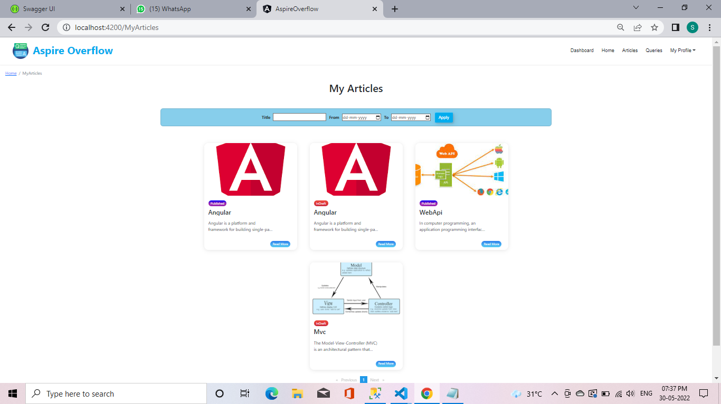

| **Description** | Purpose of the Screen - Here the User can see his article. |
| --- | --- |
| **Security Group** | List the security groups that may use the screen |
| **Data** | Title:- Here the user can mention article title to see that particular article.  Date:- Here the user can enter the specific date to view that particular article. |
| **Actions** | My Profile: - Here the user can see his Profile.  Articles: - Here the User can click articles means It can go to Article page and see more articles here.  Queries: - Here the User can click queries means it can go to Query page and view more query here.  Apply button:- After user enter Article title.then user click apply button if it is available means shown otherwise not shown.  Read more:- Here the user click read more means,It should view full article. |

**SCREEN 10:- MY QUERY**

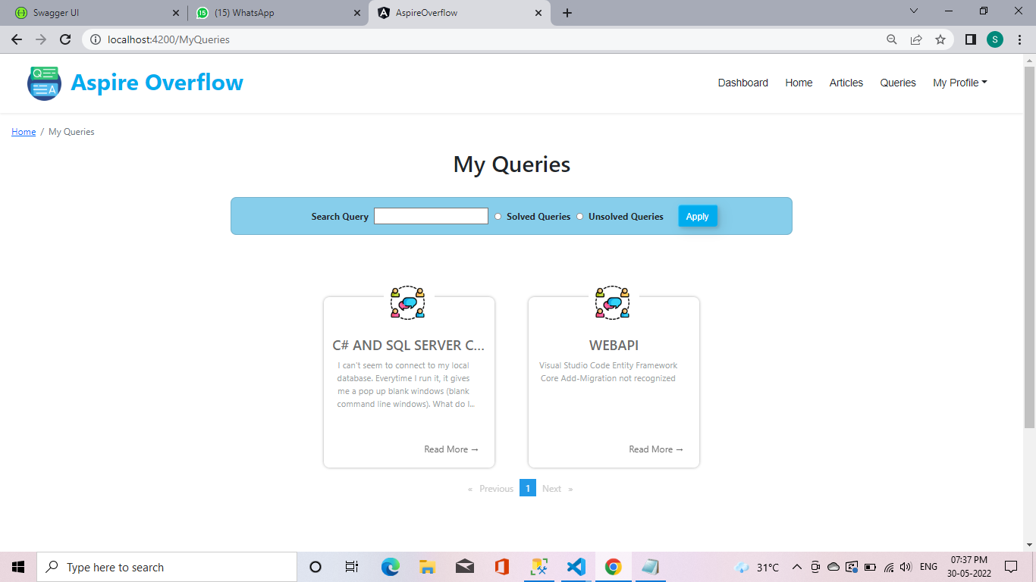

| **Description** | Purpose of the Screen - Here the User can see his query. |
| --- | --- |
| **Security Group** | List the security groups that may use the screen |
| **Data** | Search query: - Here the user can search query based on what he/she need. If that user searched query available means user can use the query. Suppose if that query not available means that query should be marked as unsolved.  Solved queries: - Here the user can view all the solved queries and also user can answer the queries if user know the additional answers.  Unsolved queries: - Here the user can view the unsolved queries and also user can give the answer if he/she know the queries answer. |
| **Actions** | My Profile: - Here the user can see his Profile.  Articles: - Here the User can click articles means It can go to Article page and see more articles here.  Read more: - Here the user click read more means,It should view full query .  Queries: - Here the User can click queries means it can go to Query page and view more query here.  Apply button: - After user enter query.then user click apply button.If it is available means shown otherwise not shown. |

**SCREEN 11: - RAISE QUERY**

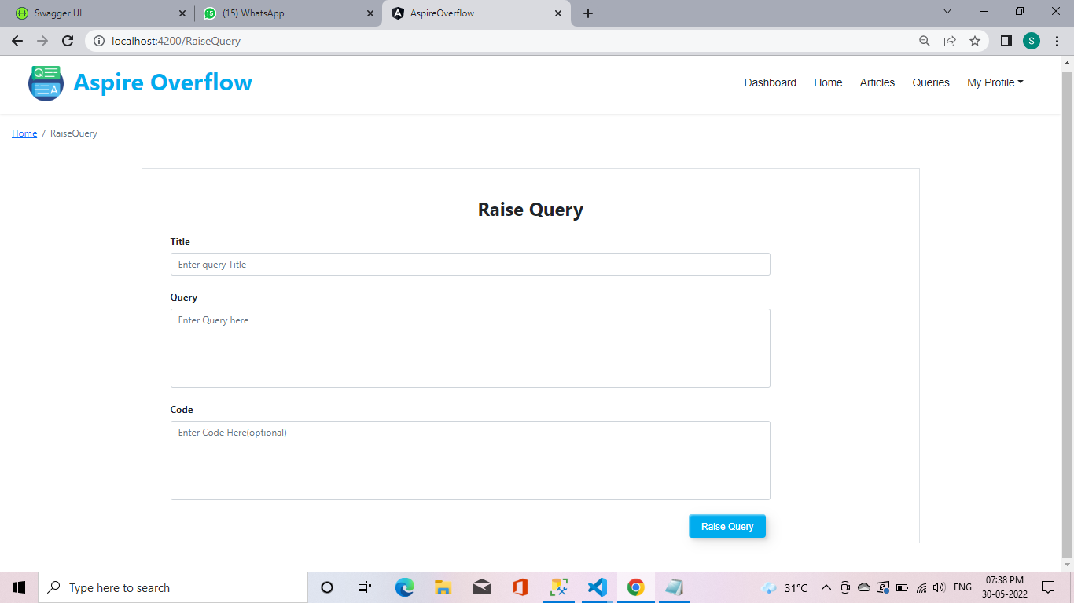

| **Description** | Purpose of the Screen - Here the User can raise query. |
| --- | --- |
| **Security Group** | List the security groups that may use the screen |
| **Data** | Title: - Here the user can enter the title which topic he/she can raise query. It is a required one.  Query: - Here user can raise a question. It is a required one.  Code: - Here user can write a code if he/she have doubt in coding part.It is an optional |
| **Actions** | My Profile: - Here the user can see his Profile.  Articles: - Here the User can click articles means It can go to Article page and see more articles here.  Queries: - Here the User can click queries means it can go to Query page and view more query here.  Raise query button: - After user enter query, then user click raise query button. The query will be raised in query page. |

**SCREEN 12:- LATEST ARTICLES**

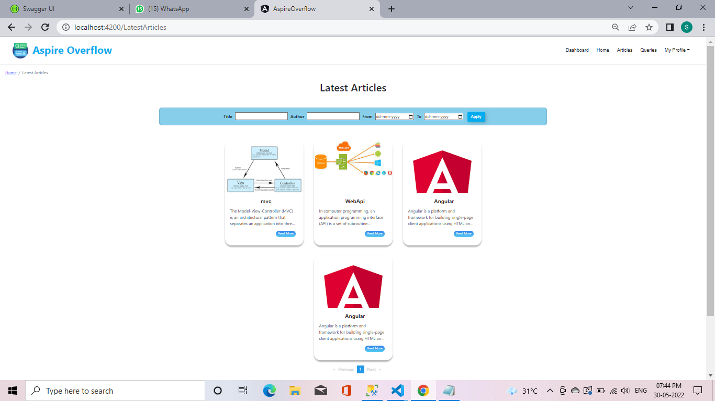

| **Description** | Purpose of the Screen - Here the User can see Latest articles. |
| --- | --- |
| **Security Group** | List the security groups that may use the screen |
| **Data** | Title: - Article should be shown based on the title given by the user.  Author: - Here the article should be shown based on that author name given by the user.  Date: - Here the user should give the date (From – To). Based on that Listed articles should be shown in that particular date. |
| **Actions** | My Profile: - Here the user can see his Profile.  Articles: - Here the User can click articles means It can go to Article page and see more articles here.  Queries: - Here the User can click query means it can go to Query page and view more query here.  Read more: - Here the user click read more means, It should view full article.  Apply button: - After user enter Article name, Author name or date. Then user click apply button if it is available means shown otherwise not shown. |

**SCREEN 13: - TRENDING ARTICLES**

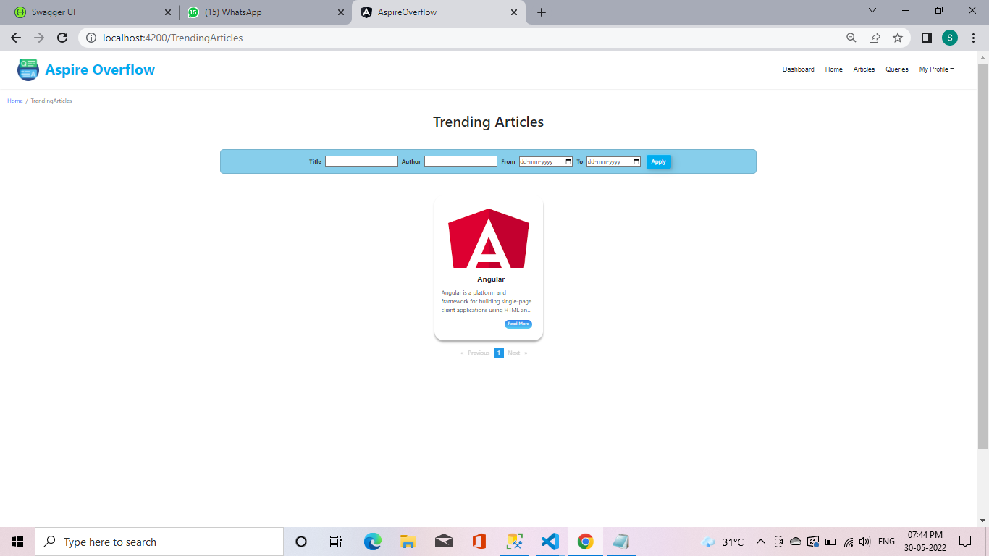

| **Description** | Purpose of the Screen - Here the User can see Trending articles. |
| --- | --- |
| **Security Group** | List the security groups that may use the screen |
| **Data** | Title: - Article should be shown based on the title given by the user.  Author: - Here the article should be shown based on that author name given by the user.  Date: - Here the user should give the date (From – To). Based on that Listed articles should be shown in that particular date. |
| **Actions** | My Profile: - Here the user can see his Profile.  Articles: - Here the User can click articles means It can go to Article page and see more articles here.  Queries: - Here the User can click queries means it can go to Query page and view more query here.  Read more: - Here the user click read more means, It should view full article.  Apply button: - After user enter Article name, Author name or date. Then user click apply button if it is available means shown otherwise not shown. |

**SCREEN 14: - LATEST QUERIES**

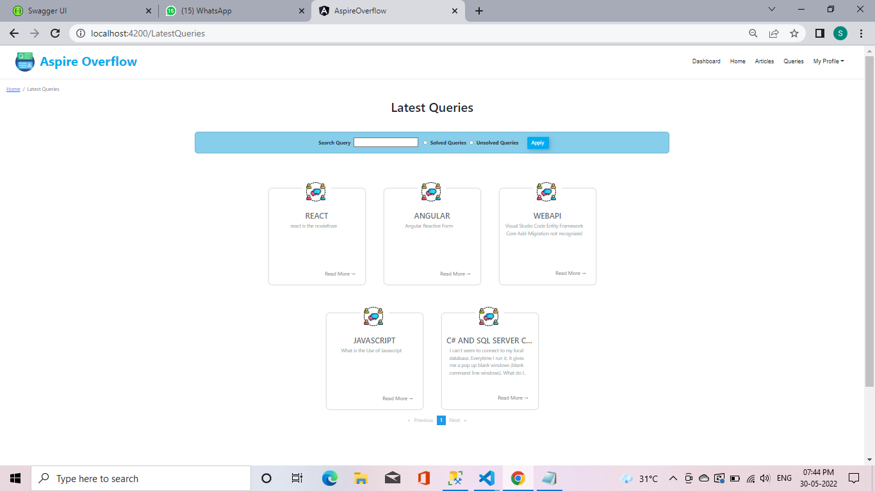

| **Description** | Purpose of the Screen - Here the User can see Latest queries. |
| --- | --- |
| **Security Group** | List the security groups that may use the screen |
| **Data** | Search query: - Here the user can search query based on what he/she need. If that user searched query available means user can use the query. Suppose if that query not available means that query should be marked as unsolved.  Solved queries: - Here the user can view all the solved queries and also user can answer the queries if user know the additional answers.  Unsolved queries: - Here the user can view the unsolved queries and also user can give the answer if he/she know the queries answer. |
| **Actions** | My Profile: - Here the user can see his Profile.  Articles: - Here the User can click articles means It can go to Article page and see more articles here.  Read more:- Here the user click read more means, It should view full query .  Queries: - Here the User can click queries means it can go to Query page and view more query here.  Apply button:- After user enter query. Then user click apply button. If it is available means shown otherwise not shown. |

**SCREEN 15: - MY PROFILE**

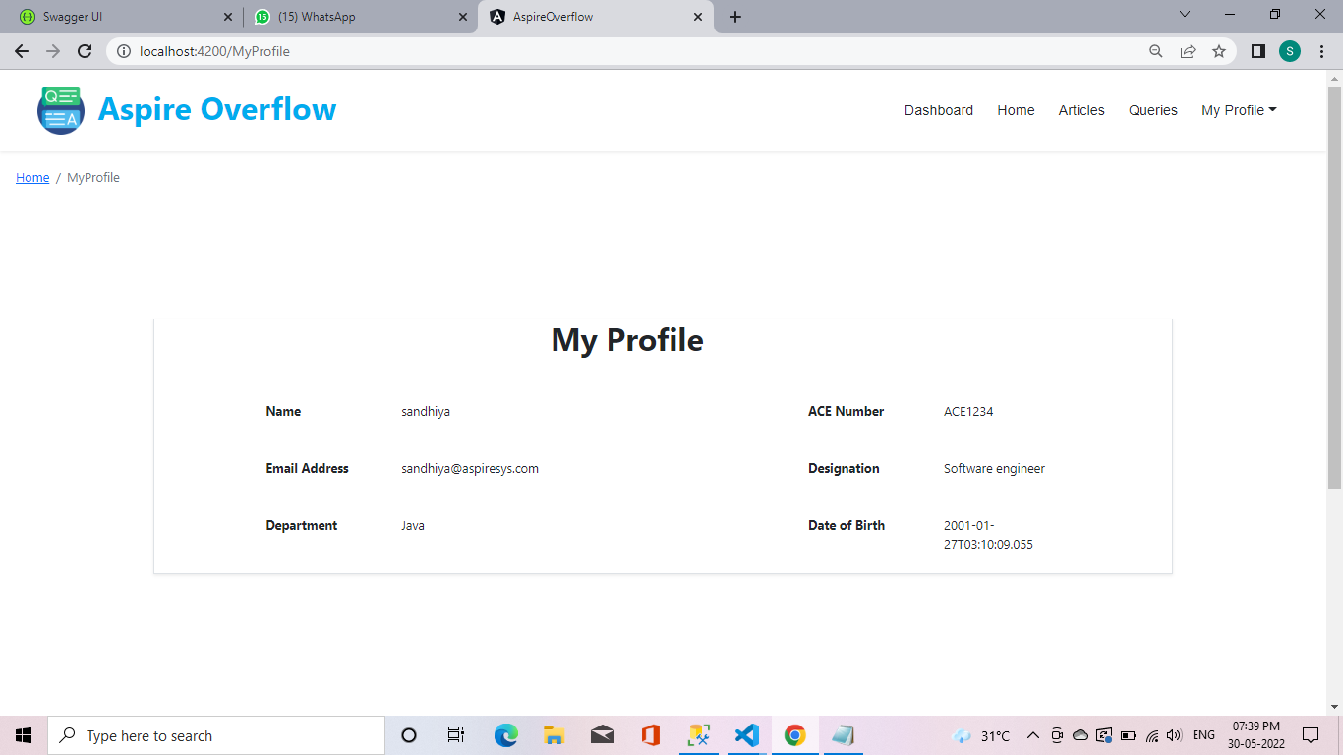

| **Description** | Purpose of the Screen - Here the User can see his profile. |
| --- | --- |
| **Security Group** | List the security groups that may use the screen |
| **Data** | In my profile page the user can see his Name, Email Address, Department, ACE Number, Designation and Date of birth |
| **Actions** | My Profile: - Here the user can see his Profile.  Articles: - Here the User can click articles means It can go to Article page and see more articles here.  Queries: - Here the User can click queries means it can go to Query page and view more query here. |

**SCREEN 16:- SPECIFIC ARTICLE**

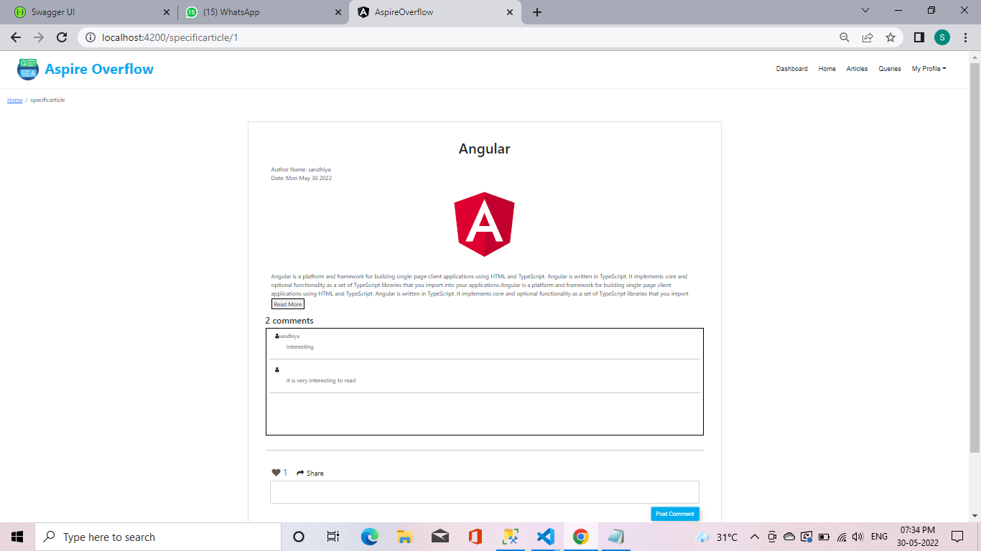

| **Description** | Purpose of the Screen - Here the user can view the particular article and also user can add comment. |
| --- | --- |
| **Security Group** | List the security groups that may use the screen |
| **Data** | Here the user can view particular article and also in top right side the article author name and published date mentioned.  Comment: - Here the user can write the comment, and also user can view comment if anyone written already.  Share: - Here the user can also share this article to anyone.  Likes: - Here the user can also like the article. |
| **Actions** | My Profile: - Here the user can see his Profile.  Articles: - Here the User can click articles means It can go to Article page and see more articles here.  Queries: - Here the User can click queries means it can go to Query page and view more query here.  Read more: - Here the user click read more means, it should view full article.  Post Comment: - Here the user writes the comment and enter the post comment button means, it should be posted. If user cannot comment anything and click post comment button, it mentioned as Comment should be required one. |

**SCREEN 17: - OVERVIEW OF DASHBOARD**

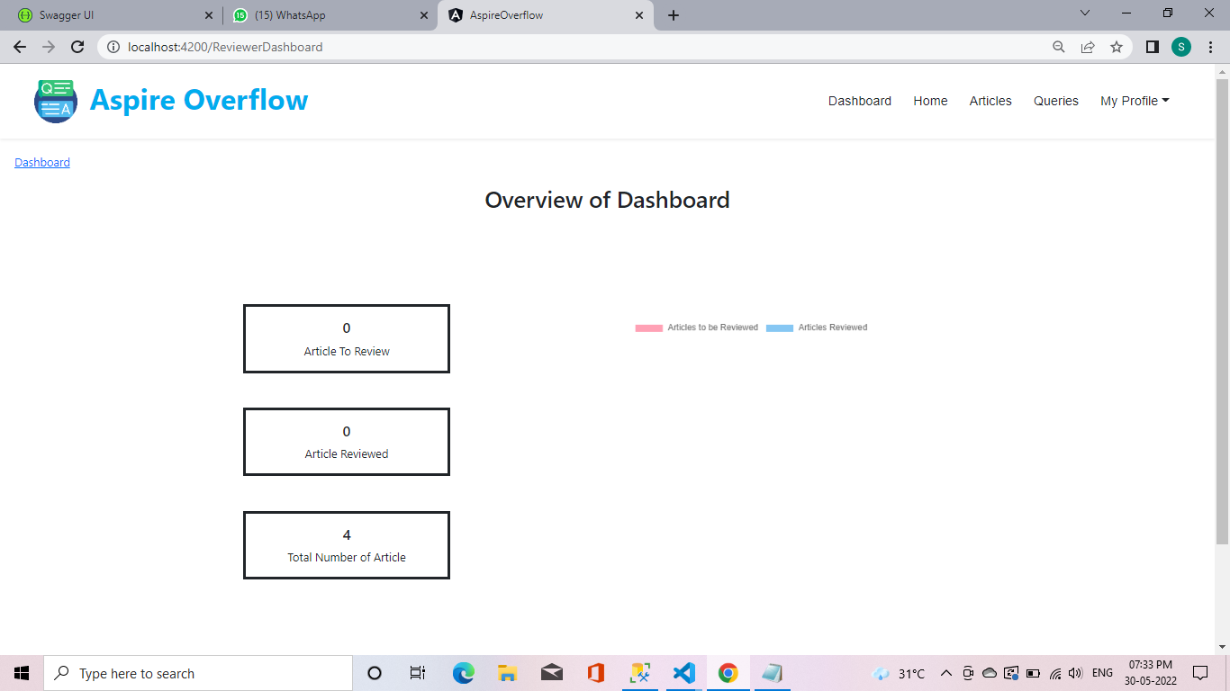

| **Description** | Purpose of the Screen - Here the user can see Overview of dashboard such as published articles, yet to reviewed articles. |
| --- | --- |
| **Security Group** | List the security groups that may use the screen |
| **Data** | Article to review: - Here the user can see the articles which are not reviewed.  Articles reviewed: - Here the user can see the articles which are reviewed.  Total number of articles: - Here the user can see the total number of articles published. |
| **Actions** | My Profile: - Here the user can see his Profile.  Articles: - Here the User can click articles means It can go to Article page and see more articles here.  Queries: - Here the User can click queries means it can go to Query page and view more query here.  Home: - Here the user can click home means it can go to home page and view the homepage content.  Dashboard: - Here the user can see the overview of dashboard. |

**SCREEN 18: - ARTICLE REVIEWED**

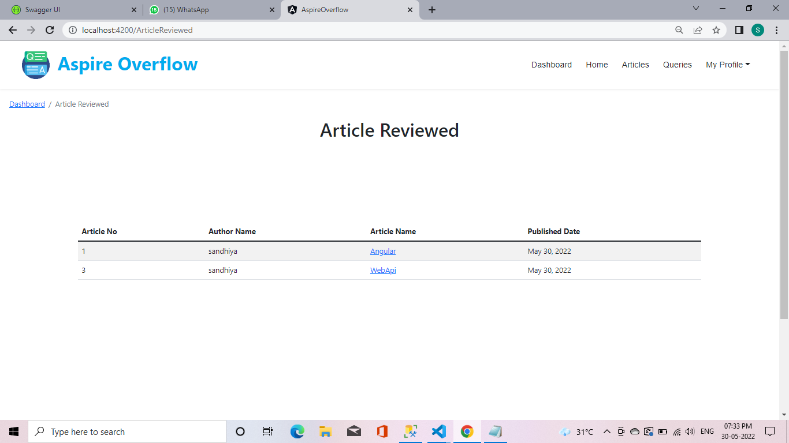

| **Description** | Purpose of the Screen - Here the reviewer can see reviewed articles. |
| --- | --- |
| **Security Group** | List the security groups that may use the screen |
| **Data** | Article No: - Here the reviewer can see the article number.  Article Name: - Here the reviewer can see the Article name.  Author Name: - Here the reviewer can see the Author name.  Published Date: - Here the reviewer can see the published date of article.  Search: - Here the reviewer can search Article No, Article Name, Author Name, Published Date whatever reviewer want. |
| **Actions** | My Profile: - Here the user can see his Profile.  Articles: - Here the User can click articles means It can go to Article page and see more articles here.  Queries: - Here the User can click queries means it can go to Query page and view more query here.  Dashboard: - Here the user can see the overview of dashboard such as published articles, yet to reviewed articles.  Home: - Here the user can click home means it can go to home page and view the homepage content. |

**SCREEN 19: - TO REVIEW**

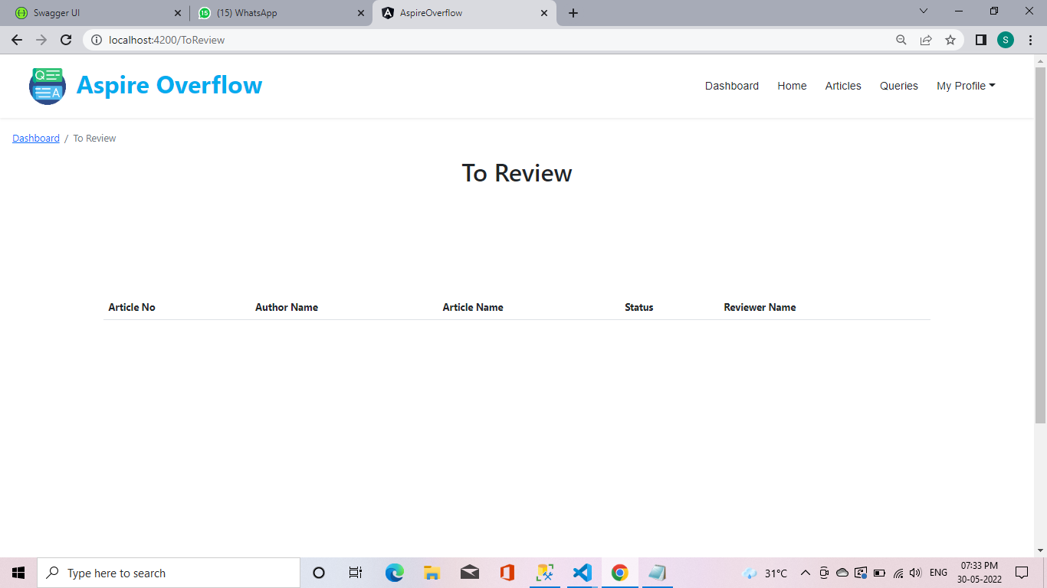

| **Description** | Purpose of the Screen - Here the reviewer can see reviewed articles. |
| --- | --- |
| **Security Group** | List the security groups that may use the screen |
| **Data** | Article No: - Here the reviewer can see the article number.  Article Name: - Here the reviewer can see the article name.  Author Name: - Here the reviewer can see the author’s name.  Article status: - Here the reviewer can see the article status (Reviewed, Under Review, Not review)  Reviewer Name: - Here the reviewer can see the reviewer’s name who is reviewed that article.  Search: - Here the reviewer can search Article No, Article Name, Author Name, Article status, Reviewer Name whatever reviewer want. |
| **Actions** | My Profile: - Here the user can see his Profile.  Articles: - Here the User can click articles means It can go to Article page and see more articles here.  Queries: - Here the User can click queries means it can go to Query page and view more query here. Dashboard: - Here the user can see the overview of dashboard such as published articles, yet to reviewed articles. Home: - Here the user can click home means it can go to home page and view the homepage content. |

**SCREEN 20: - OVERVIEW OF DASHBOARD(ADMIN)**

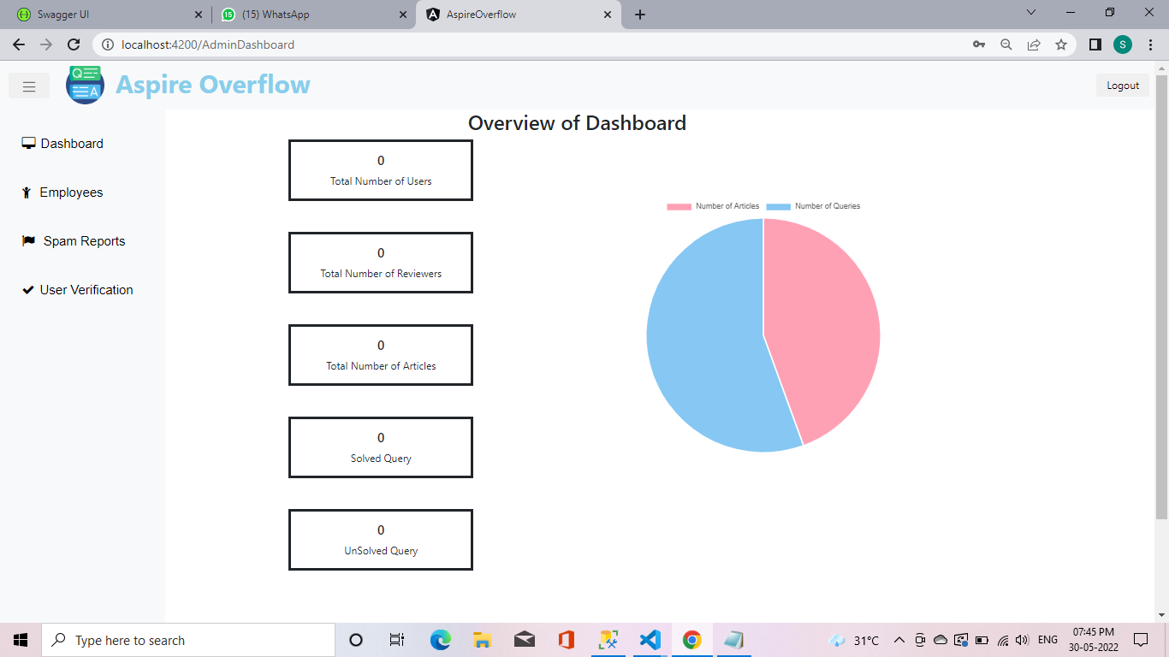

| **Description** | Purpose of the Screen - Here the user can see Overview of dashboard such as Total number of users, Total number of reviewers, Total number of articles, Solved query, Unsolved query. |
| --- | --- |
| **Security Group** | List the security groups that may use the screen |
| **Data** | Total Number of Users: - Here the admin can see the total number of users.  Total Number of Reviewers: - Here the admin can see the total number of reviewers.  Total Number of Articles: - Here the admin can see the total number of Articles.  Solved query: - Here the admin can see the total number of solved queries.  Unsolved query: - Here the admin can see the total number of unsolved queries. |
| **Actions** | Logout Button: - Here the admin clicks Logout button, His account should be log out and move to login page. |

**SCREEN 21: - USER VERIFICATION**

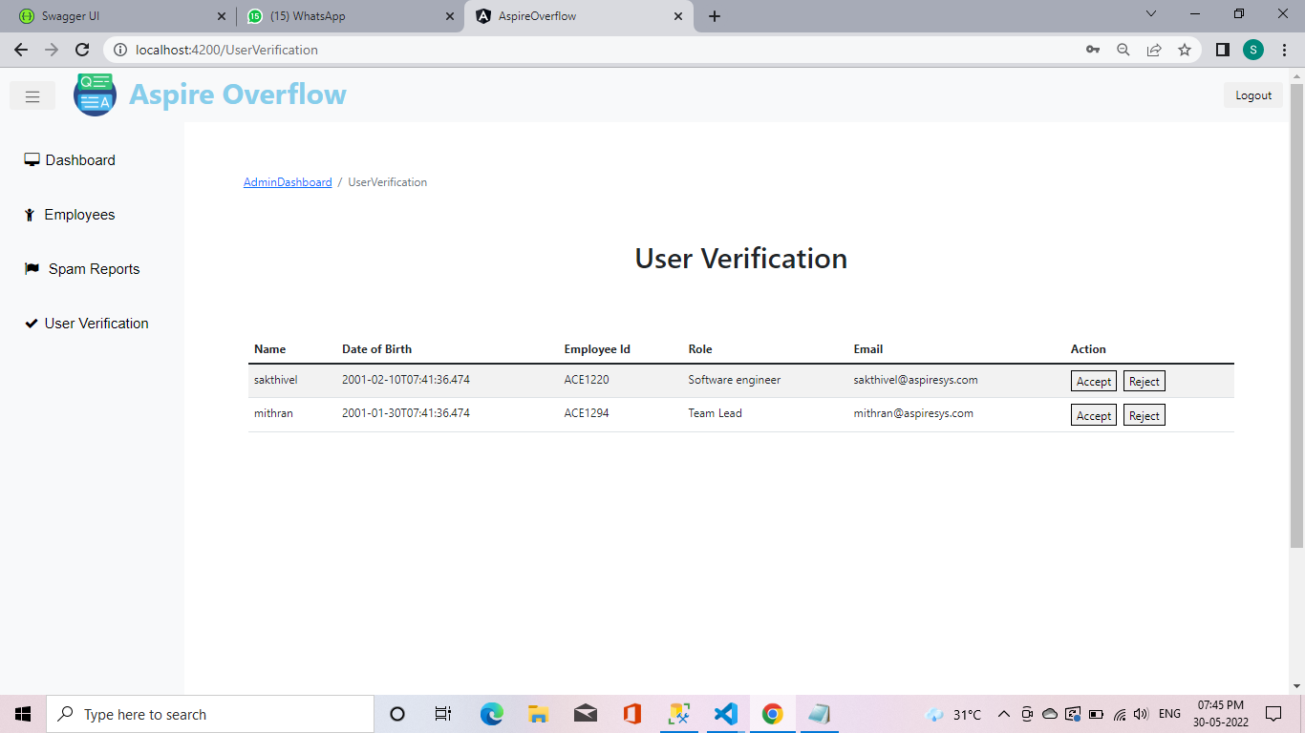

| **Description** | Purpose of the Screen - Here the Admin can see verification page such as Name, Date of birth, Employee id, Role, Email, Action. |
| --- | --- |
| **Security Group** | List the security groups that may use the screen |
| **Data** | Name: - Here the admin can see the employee’s name.  DOB: - Here the admin can see the employee date of birth.  Employee Id: - Here the admin can see the employee Id.  Role: - Here the admin can see the employee role.  Email: - Here the admin can see the employee email.  Search: - Here the admin can search Employee name, Dob, id, Role, Email whatever admin want. |
| **Actions** | Logout Button: - Here the admin clicks Logout button, His account should be log out and move to login page.  Accept button: - Here the user details are correct means, Admin should accept user request.  Reject button: - Here the user details are incorrect means, Admin should reject user request. |

**SCREEN 22: - SPAM REPORT**

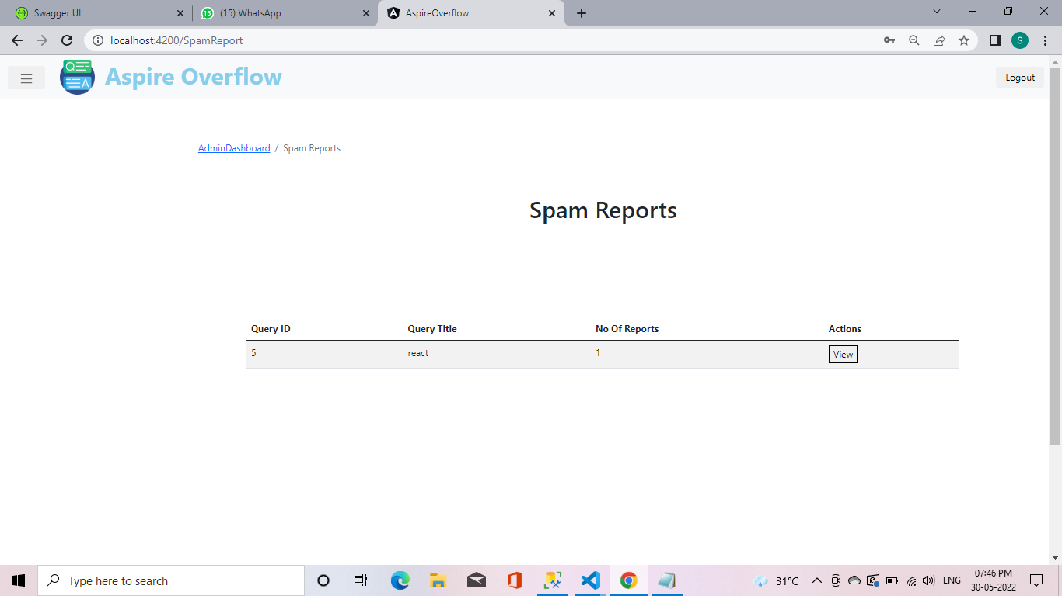

| **Description** | Purpose of the Screen - Here the Admin can see Reported spam such as Query id, Query title, no of reports, Actions. |
| --- | --- |
| **Security Group** | List the security groups that may use the screen |
| **Data** | Query ID: - Here the admin can see the query Id.  Query Title: - Here the admin can see the query Title.  No of Reports: - Here the admin can see the overall report for that query.  Search: - Here the admin can search Query id, Query title, no of reports, Actions. |
| **Actions** | Logout Button: - Here the admin clicks Logout button, His account should be log out and move to login page.  View: -Here the admin can view the reason for that query and why it is marked as spam. |

**SCREEN 23: - EMPLOYEE DETAILS**

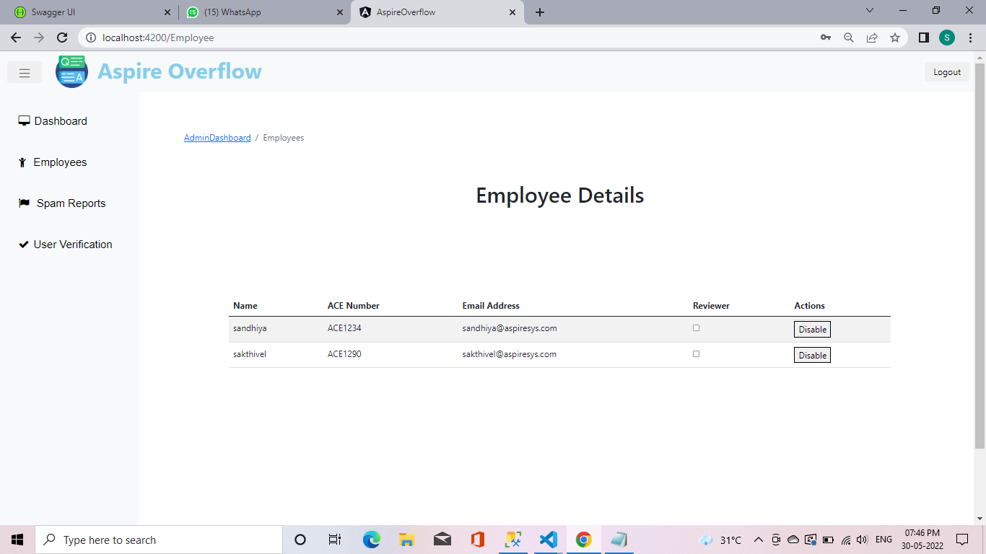

| **Description** | Purpose of the Screen - Here the Admin can see verification page such as Name, Date of birth, Employee id, Role, Email, Action. |
| --- | --- |
| **Security Group** | List the security groups that may use the screen |
| **Data** | Name: - Here the admin can see the employee’s name.  ACE Number: - Here the admin can see the employee ace number.  Email: - Here the admin can see the employee email.  Reviewer: - Here the admin can mark as that employee should be a reviewer.  Search: - Here the admin can search Employee name, Dob, id, Role, Email whatever admin want. |
| **Actions** | Logout Button: - Here the admin clicks Logout button, His account should be log out and move to login page.  Action Button: - Here the admin should disable this user. |

**SCREEN 24: - SOLVED QUERY**



| **Description** | Purpose of the Screen - Here the user can see the solved query. |
| --- | --- |
| **Security Group** | List the security groups that may use the screen |
| **Data** | Search query: - Here the user can search query based on what he/she needs. If that user searched a query available means the user can use that query. Suppose if that query is not available means that query should be marked as unsolved.  Solved queries: - Here the user can view all the solved queries and also the user can answer the queries if the user knows the additional answers. |
| **Actions** | My Profile: - Here the user can see his Profile.  Articles: - Here the User can click articles means It can go to Article page and see more articles here.  Read more: - Here the user click read more means, It should view full query.  Queries: - Here the User can click queries means it can go to Query page and view more query here.  Apply button: - After user enter query. Then user click apply button. If it is available means shown otherwise not shown.  Pagination: - Here the user clicks next page means, User can go to next page and see more queries. |

**SCREEN 25: -UNSOLVED QUERY**

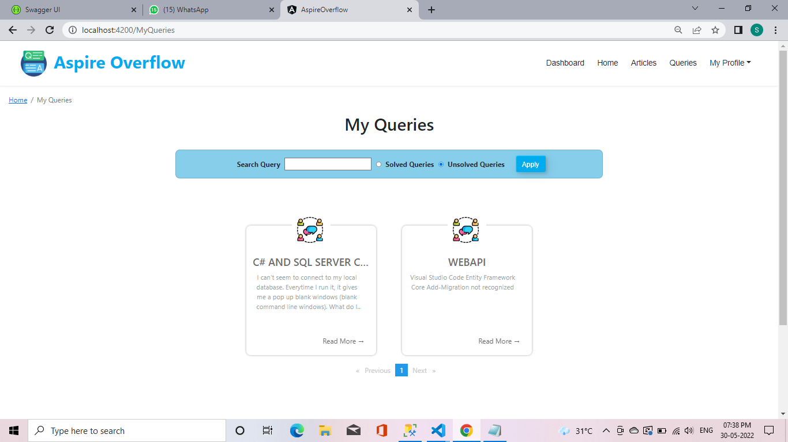

| **Description** | Purpose of the Screen - Here the User can see Unsolved query. |
| --- | --- |
| **Security Group** | List the security groups that may use the screen |
| **Data** | Search query: - Here the user can search query based on what he/she need. If that user searched query available means user can use the query. Suppose if that query not available means that query should be marked as unsolved.  Solved queries: - Here the user can view all the solved queries and also user can answer the queries if user know the additional answers.  Unsolved queries: - Here the user can view the unsolved queries and also user can give the answer if he/she know the queries answer. |
| **Actions** | My Profile: - Here the user can see his Profile.  Articles: - Here the User can click articles means It can go to Article page and see more articles here.  Read more: - Here the user click read more means, It should view full query.  Queries: - Here the User can click queries means it can go to Query page and view more query here.  Apply button: - After user enter query. then user click apply button. If it is available means shown otherwise not shown. Pagination: - Here the user clicks next page means, User can go to next page and see more queries. |

**SCREEN 26: -SPAM VIEW**

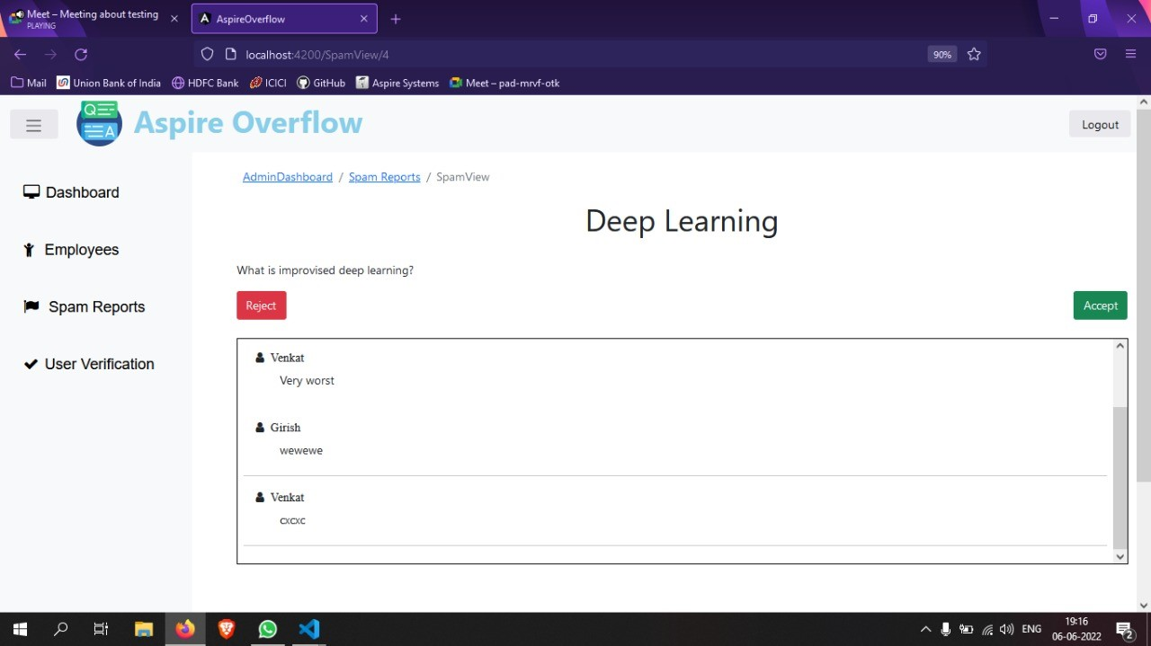

| **Description** | Purpose of the Screen - Here the Admin can see spam view page. |
| --- | --- |
| **Security Group** | List the security groups that may use the screen |
| **Data** | Here the admin can view that query and see how many of them reported that query as spam.  And also, admin can view reason why the user can mark that query as spam.  Admin can also see the user’s name and comment.  If that query is bad means, Admin should reject otherwise admin cannot reject that query |
| **Actions** | Logout Button: - Here the admin clicks Logout button, His account should be log out and move to login page.  Reject Button: - Here the admin click reject button, that query should be removed from spam page and view in queries page.  Accept Button: - Here the admin click accept button, that query should be dismissed. |

**SCREEN 27: -TRENDING QUERIES**

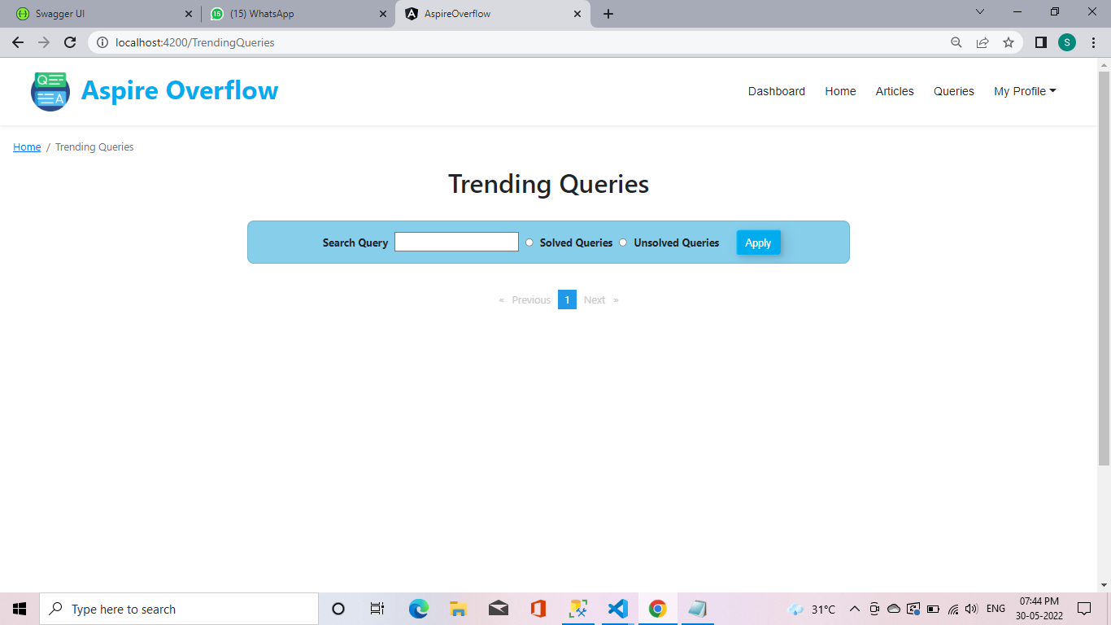

| **Description** | Purpose of the Screen - Here the User can see Trending queries. |
| --- | --- |
| **Security Group** | List the security groups that may use the screen |
| **Data** | Search query: - Here the user can search query based on what he/she need. If that user searched query available means user can use the query. Suppose if that query not available means that query should be marked as unsolved.  Solved queries: - Here the user can view all the solved queries and also user can answer the queries if user know the additional answers.  Unsolved queries: - Here the user can view the unsolved queries and also user can give the answer if he/she know the queries answer. |
| **Actions** | My Profile: - Here the user can see his Profile.  Articles: - Here the User can click articles means It can go to Article page and see more articles here.  Read more: - Here the user click read more means, It should view full query.  Queries: - Here the User can click queries means it can go to Query page and view more query here.  Apply button: - After user enter query. then user click apply button. If it is available means shown otherwise not shown. Pagination: - Here the user clicks next page means, User can go to next page and see more queries. |

## **Reports**

| **Description** | Describe the purpose of the report as to ensure the client and developer agrees on its functionality. |
| --- | --- |
| **Security Group** | List the security groups that may use the report |
| **Data** | Describe each field on the report and how it is derived |
| **Groupings** | Describe how the report should be grouped and/or sorted |
| **Totals** | Describe the sub and grand totals needed on the report |
| **Filters** | Describe any filter or selection criteria needed for the report. How is this selection criteria entered? |
| **Export Formats** | Describe the export format of the report (print preview, printer, MS Word, MS Excel, HTML, etc.) |
| **Frequency** | If this report should be run periodically, specify the frequency (Daily, Weekly, Monthly, Quarterly, Yearly, On Demand) |

# **Business Layer**

< Define all of the objects necessary to support the presentation layer. First show the object hierarchy then include file that shows the details>

# **Database Layer**

**Table 1 : Department**

| **Field Name** | **Data type** | **Constraints** | **Description** |
| --- | --- | --- | --- |
| DepartmentID | varchar(10) | Primary key | Unique ID for each Department |
| DepartmentName | varchar(20) | Not null | Name of the department |

**Table 2 : Designation**

| **Field Name** | **Data type** | **Constraints** | **Description** |
| --- | --- | --- | --- |
| DesignationID | varchar(10) | Primary key | Unique ID for each Designation |
| DesignationName | varchar(20) | Not null | Name of the designation |
| DepartmentID | varchar(10) | Foreign key | The ID of the department for which this designation will come under |

**Table 3 : Gender**

| **Field Name** | **Data type** | **Constraints** | **Description** |
| --- | --- | --- | --- |
| GenderID | varchar(10) | Primary key | Unique ID for each gender |
| GenderName | varchar(20) | Not null | Name of the gender |

**Table 4 : User Role**

| **Field Name** | **Data type** | **Constraints** | **Description** |
| --- | --- | --- | --- |
| UserRoleID | varchar(10) | Primary key | Unique ID for each User Role |
| RoleName | varchar(20) | Not null | Name of the Role |

**Table 5 : Article Status**

| **Field Name** | **Data type** | **Constraints** | **Description** |
| --- | --- | --- | --- |
| StatusID | varchar(10) | Primary key | Unique ID for each status of the article |
| Status | varchar(20) | Not null | Name of the status |

**Table 6 : Verify Status**

| **Field Name** | **Data type** | **Constraints** | **Description** |
| --- | --- | --- | --- |
| VerifyStatusID | varchar(10) | Primary key | Unique ID for each status |
| Name | varchar(20) | Not null | Name of the status |

**Table 7 : User**

| **Field Name** | **Data type** | **Constraints** | **Description** |
| --- | --- | --- | --- |
| UserID | Varchar(10) | Primary key | Unique ID for each User |
| FullName | varchar(20) | Not null | Name of the User |
| GenderID | Varchar(10) | Foreign key | Gender ID to identify the gender of the specific user |
| ACE Number | Varchar(30) | Not null | ACE Number of the specific User |
| Email Address | varchar(50) | Not null | Email Address for the user |
| Password Hash | varchar(20) | Not null | Password which is given by the user during registration is hashed |
| Date of Birth | date | Not null | The date of birth of the user |
| IsVerified | bit | Not null | Determines whether the user is approved to login |
| UserRoleID | varchar(10) | Foreign key | ID to determine the Role of the User |
| DepartmentID | varchar(10) | Foreign key | ID to specify the department of the user |

**Table 8 : Private Articles**

| **Field Name** | **Data type** | **Constraints** | **Description** |
| --- | --- | --- | --- |
| ID | varchar(10) | Primary key | Unique ID for each Private Article |
| Article Id | varchar(20) | Not null | ID of the Article |
| User Id | Varchar(10) | Not null | User ID of the person who  creates the Private Article |

**Table 9 : Articles**

| **Field Name** | **Data type** | **Constraints** | **Description** |
| --- | --- | --- | --- |
| ArticleID | varchar(10) | Primary key | Unique Id for all the articles created |
| Title | varchar(20) | Not null | Title for the specific Article |
| Content | text | Foreign key | The content or body of the article |
| Image | image | Not null | Any images that are attached to the article |
| UserId -Author | integer | Foreign key | The user-id of the author who created the specific article |
| StatusID | varchar(10) | Foreign key | The specific StatusID for the article |
| DateTime | datetime | Foreign key | The published Date and Time of the article will be described |
| UserID- Reviewer | varchar(10) | Foreign key | The user-id of the reviewer who reviewed the article |

**Table 10 : Article Rating**

| **Field Name** | **Data type** | **Constraints** | **Description** |
| --- | --- | --- | --- |
| ID | varchar(10) | Primary key | Unique Id for all the articles Published articles |
| Number of Likes | integer |  | The Number of likes for a specific article will be specified |
| Number of Dislikes | integer |  | The Number of Dislikes for the specific article will be specifies |
| ArticleID | varchar(10) | Foreign key | The ArticleID of the specific               article will be specified |

**Table 11 : Article Comment**

| **Field Name** | **Data type** | **Constraints** | **Description** |
| --- | --- | --- | --- |
| CommentID | varchar(10) | Primary key | Unique Id for all the comments for a specific  article will be specified |
| Content | text | Not null | The content of the comment will be displayed |
| DateTime | datetime | Not null | The commented date and time will be specified |
| ArticleID | varchar(10) | Foreign key | The ArticleID of the specific  article for which the  comment has been raised |
| UserID | varchar(10) | Foreign key | The user-id of the user who has commented for the specific article |

**Table 12  : Query**

| **Field Name** | **Data type** | **Constraints** | **Description** |
| --- | --- | --- | --- |
| QueryID | varchar(10) | Primary key | Unique Id for each query |
| Title | varchar(20) | Not null | Title for the specific query |
| Content | Varchar() | Foreign key | The content or body of the query |
| Code | varchar() |  | Any code that are attached in the query |
| UserId -Author | varchar(10) | Foreign key | The user-id of the user who created the specific query |
| IsSolved | bit | Not null | Determines whether the             query has been solved or             not |

**Table 13 : Query Comment**

| **Field Name** | **Data type** | **Constraints** | **Description** |
| --- | --- | --- | --- |
| CommentID | varchar(10) | Primary key | Unique Id for all the comments for a specific  query will be specified |
| Content | text | Not null | The content of the comment will be displayed |
| DateTime | datetime | Not null | The commented date and time will be specified |
| QueryID | varchar(10) | Foreign key | The QueryID of the specific query for which the   comment has been raised |
| UserID | varchar(10) | Foreign key | The user-id of the user who has commented for the specific query |

**Table 14 : Spams**

| **Field Name** | **Data type** | **Constraints** | **Description** |
| --- | --- | --- | --- |
| SpamID | varchar(10) | Primary key | Unique Id for all the spams |
| Title | varchar(20) | Not null | The title of the Spam will be described |
| Content | text | Not null | The content of the spam will be displayed |
| UserID | varchar(10) | Foreign key | The user-id of the user who has reported for the specific query |
| QueryID | varchar(10) | Foreign key | The QueryID of the specific   query for which Spam has been raised |
| IsAccepted | bit | Not null | True if the spammed query is accepted as spam |
| IsRejected | bit | Not null | True if the spammed query is not accepted as spam |

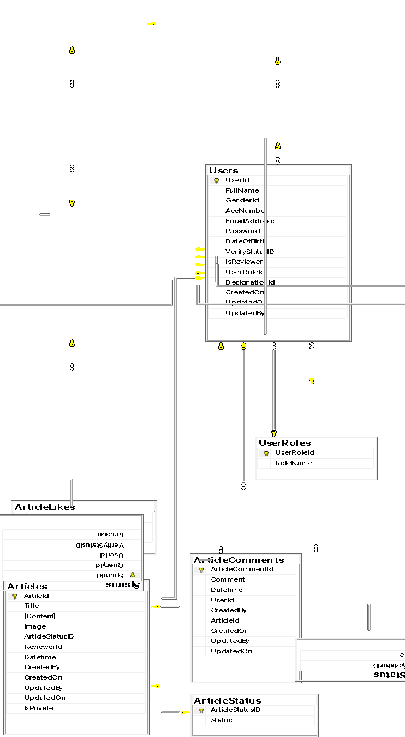

# **Detailed Design for Functional Requirement Cross Reference Matrix**

|  |  |
| --- | --- |
| **Functional Requirement** | **Detailed Design** |
| 1. Any one can write an article. | Screen 8: Create Article. |
| 2. Any one can Raise a query. | Screen 11: Raise Query. |
| 3.Reviewer can able to review the article before publishing. | Screen 19: To Review. |
| 4.Author can save the article in draft. | Screen 8: Create Article Page -> Save as draft. |
| 5.User can report query as spam and also mention the reason. | Screen 7: Reason for report. |
| 6.Reviewer can reject the article if the article content was not good. | Screen 19: To Review -> Status |
| 7.Reviewer can publish the approved article. | Screen 19: To Review -> Status. |
| 8.User can view his article. | Screen 9: My Articles. |
| 9.User can view his query. | Screen 10: My Queries. |
| 10.User can view Latest article. | Screen 12: Latest Articles. |
| 11. User can View Latest Query. | Screen 14: Latest Queries. |
| 12.User can view Trending Articles. | Screen 13: Trending Articles. |
| 13.User can view Trending Queries | Screen 27: Trending Queries. |
| 14.User can view solved and Unsolved query. | Screen 5: Queries -> Solved.  Queries->Unsolved. |
| 15.User can search query if required. | Screen 5: Queries ->Search Query. |
| 16.User can search article by Author name. | Screen 4: Articles ->Author. |
| 17.User can search article by Title. | Screen 4: Articles -> Title. |
| 18.User can search article by Date. | Screen 4: Articles -> From, To date. |
| 19.User can add comments or answer the query. | Screen 6: View specific query  ->Comments |
| 20.Admin can view the overall dashboard. | Screen 20-> Overview of dashboard |
| 21.Admin can approve the employee who register. | Screen 21 -> User Verification |
| 22.Admin can view and delete the spam content. | Screen 22-> Spam report. |
| 23.Admin can manage the employee. | Screen 23 -> Employee details. |
|  |  |

# **Build Process**

< Details of Source Code, the tools used for uploading / downloading, build and publish locations etc>

Details of Source Code: GITHUB

The tools used for uploading / downloading: GITHUB

Build and publish locations: Azure or AWS

# 